Mongo DB Notes

Favors consistency over availability. Single Master which then copies itself to the secondary servers. There needs to be a majority of servers that agree which one is the master so you cannot have an even number. Sometimes people make ‘arbiter’ servers that simply vote on who the master server is.

A MongoDB database contain collections, which can contain documents.

Secondaries can elect a new primary within seconds if your primary goes down. Make sure operation log is long enough to give you time to recover the primary when it comes back.

Delayed secondaries can be set up as insurance against people doing dumb things.

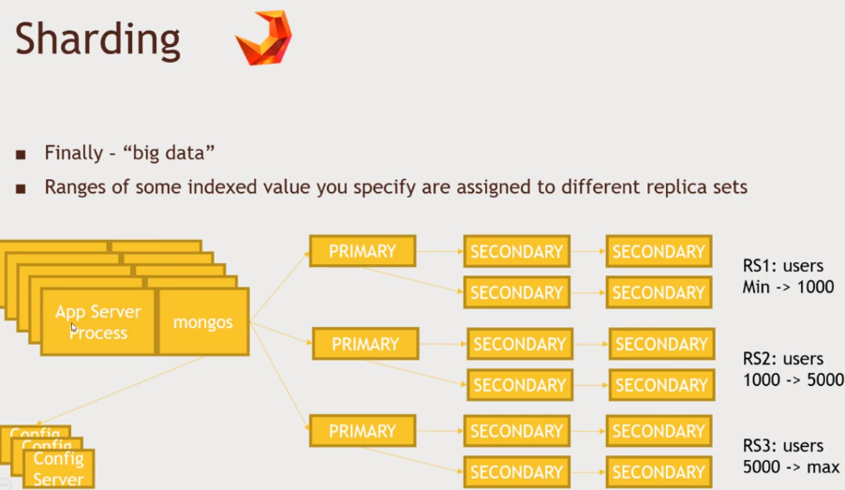Sharding – Big data

Ranges of some indexed value you specify are assigned to different sets. There is something called mongos. In mongos, it takes to the app config servers and finds out exactly which replica set do we talk to, to get the information that we want.

Mongos runs something called a balancer. It chooses how to adjust your limits.

Auto-sharding where they rebalance large amounts of data sometimes fail. Split-storms occur when the database just restarts instead.

You must have 3 config servers to complete sharding.

* If any goes down, your DB is down.
* This is the top of the single-master design of replica sets.

